**AZURE COSMOS DB**

Azure Cosmos DB is Microsoft's globally distributed multi-model database service. You can use Azure Cosmos DB to quickly create and query key/value databases, document databases, and graph databases, all of which benefit from the global distribution and horizontal scale capabilities at the core of Azure Cosmos DB.

## **Create an Azure Cosmos DB account**

1. From the Azure portal menu or the home page, select Create a resource.
2. On the New page, search for and select Azure Cosmos DB.
3. Click on Create.

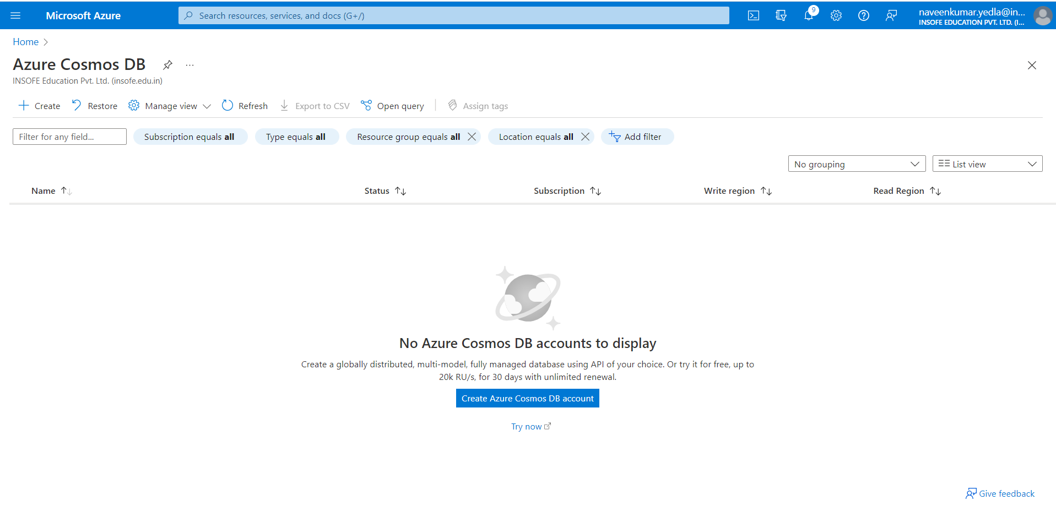

1. In the Create Azure Cosmos DB Account page, Click on Azure Cosmos DB for NoSQL.

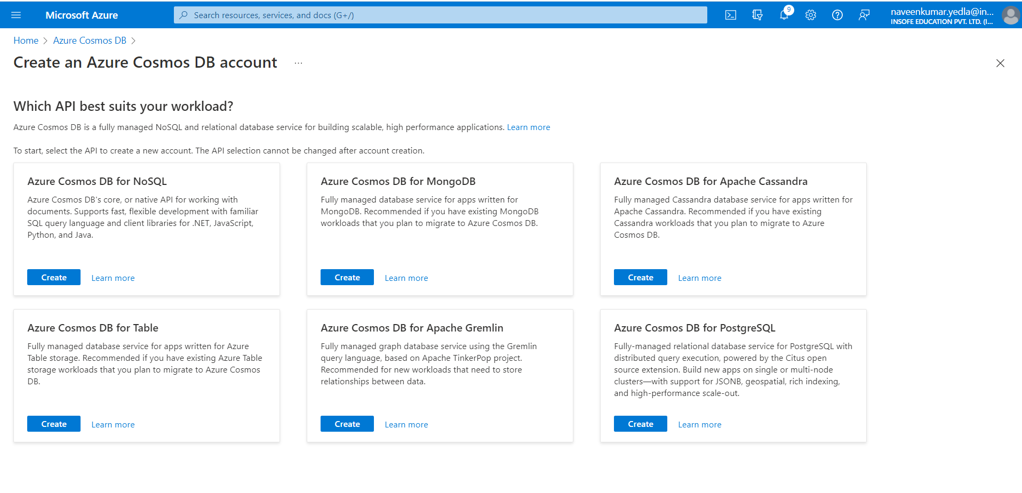

1. Subscription name : Select the Azure subscription that you want to use for this Azure Cosmos DB account.
2. Resource group name: Select a resource group, or select Create new, then enter a unique name for the new resource group.
3. A unique name: Enter a name to identify your Azure Cosmos DB account. Because documents.azure.com is appended to the name that you provide to create your URI, use a unique name.

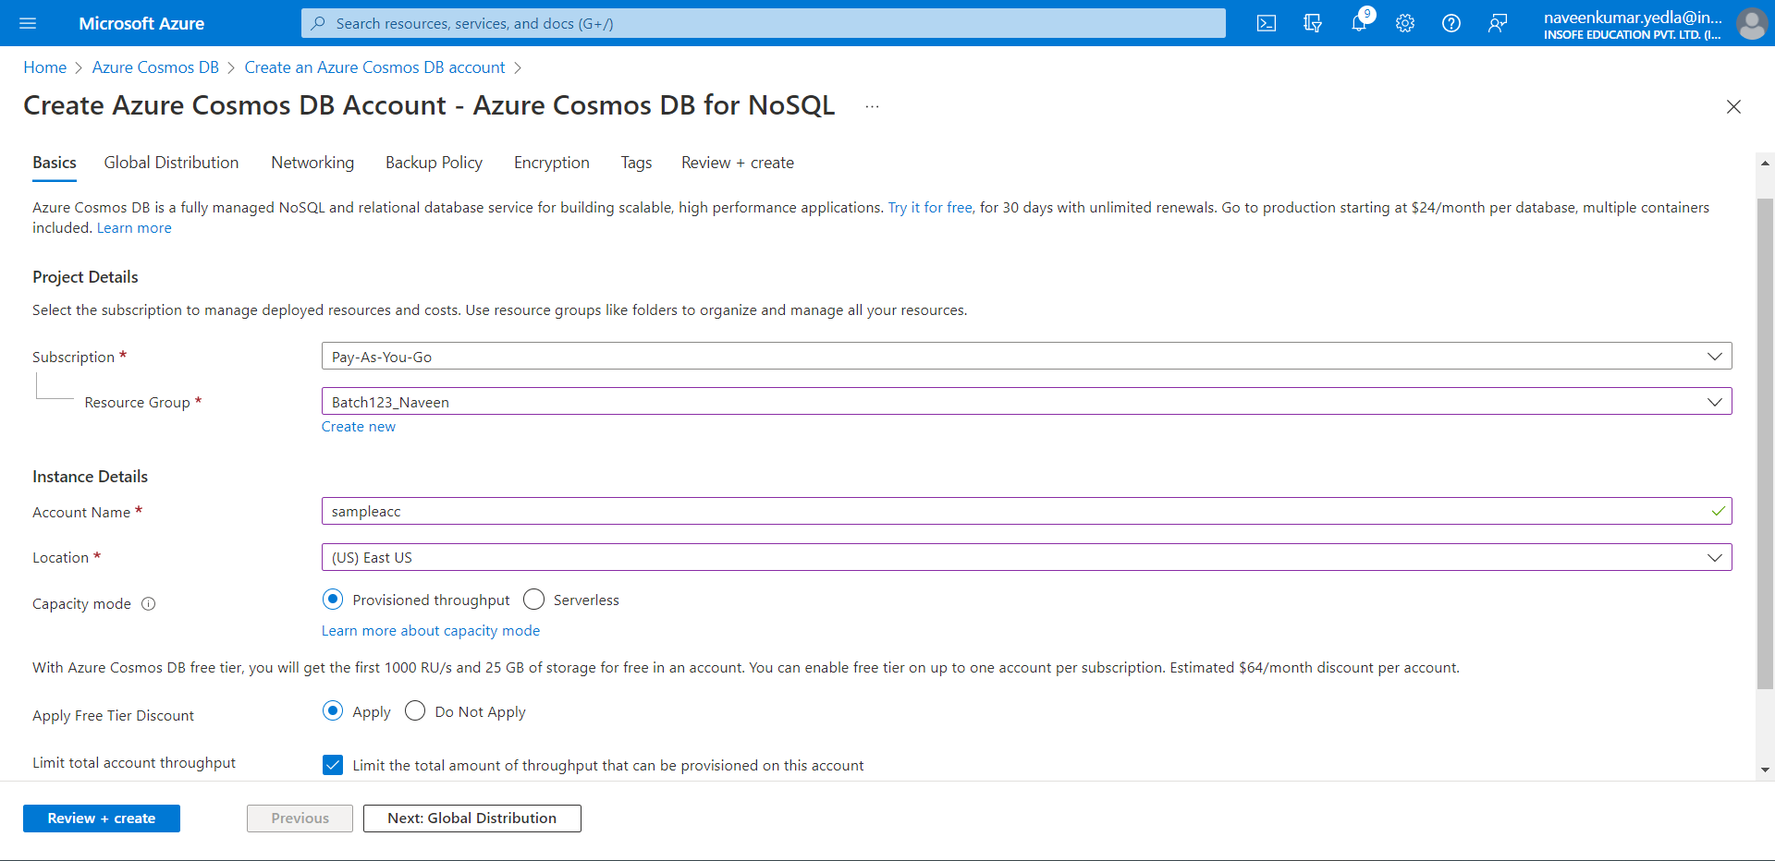

1. Optionally you can configure more details in the following tabs.
2. Go with Default options.
3. Select on Review + create and validation done. Click on Create.

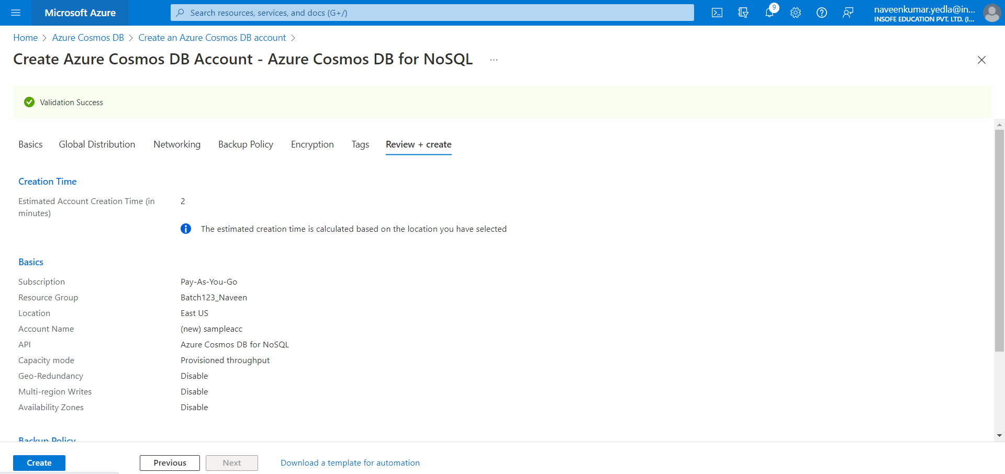

1. After deployment is complete. Go to resource to go to the Azure Cosmos DB account page.

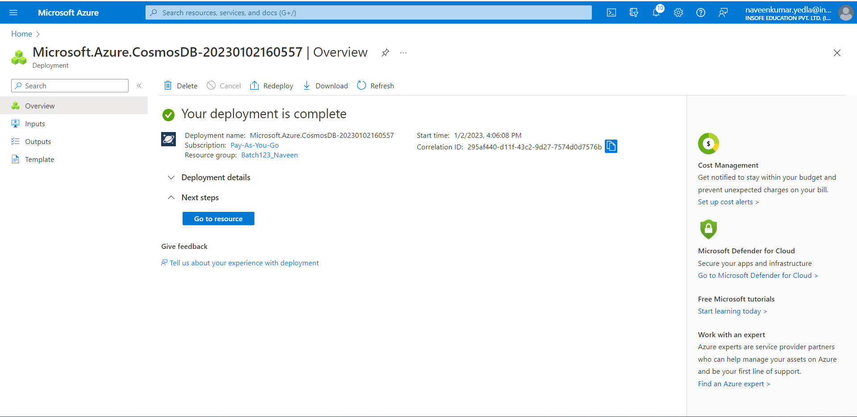

1. Select on Quick start and click on create ‘items’ container.

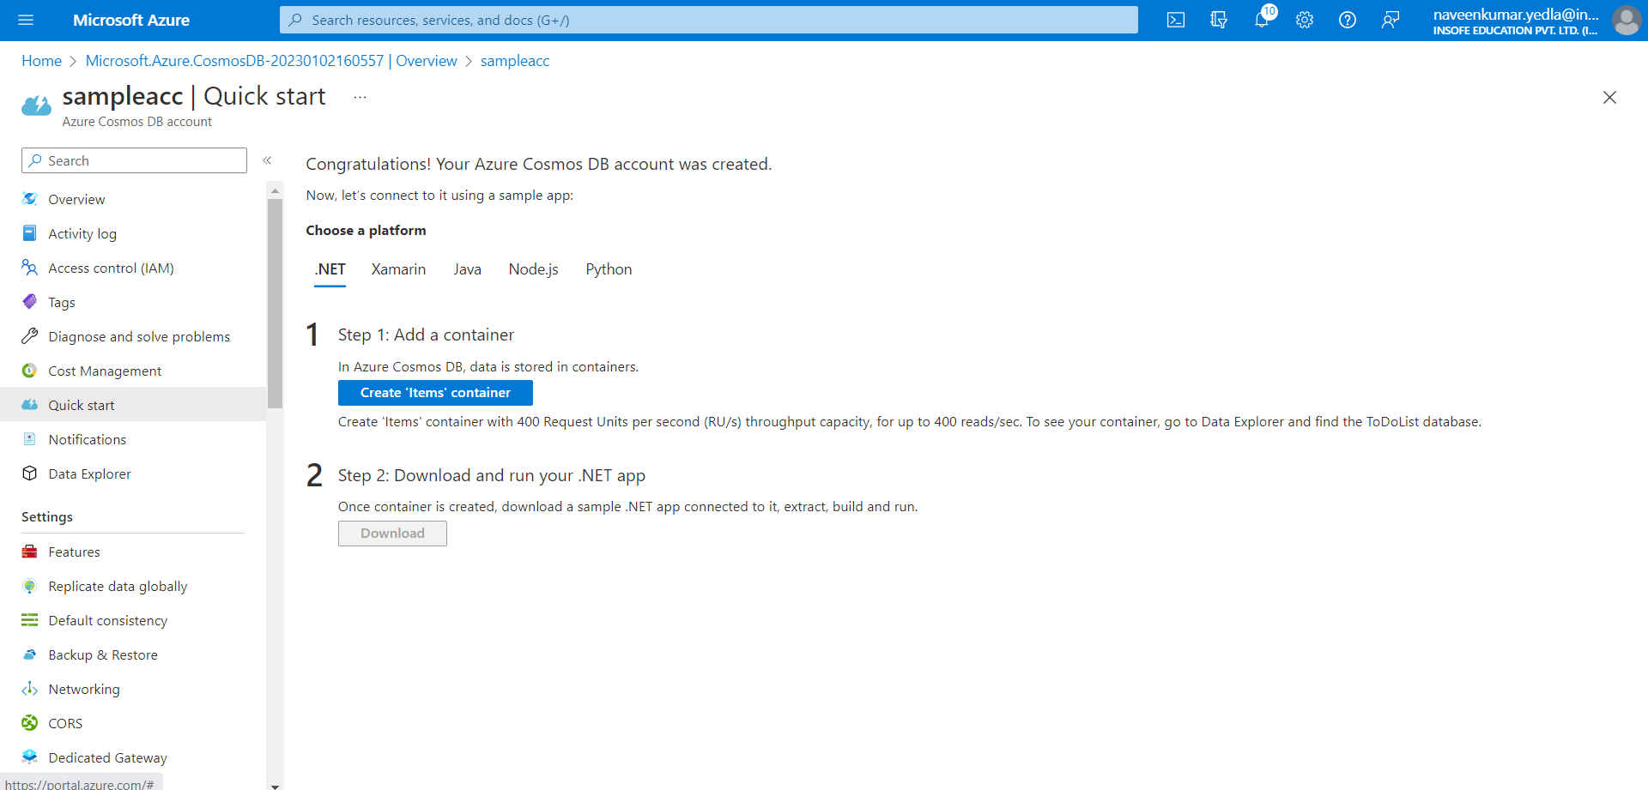

1. Select Data Explorer and click on New Container.

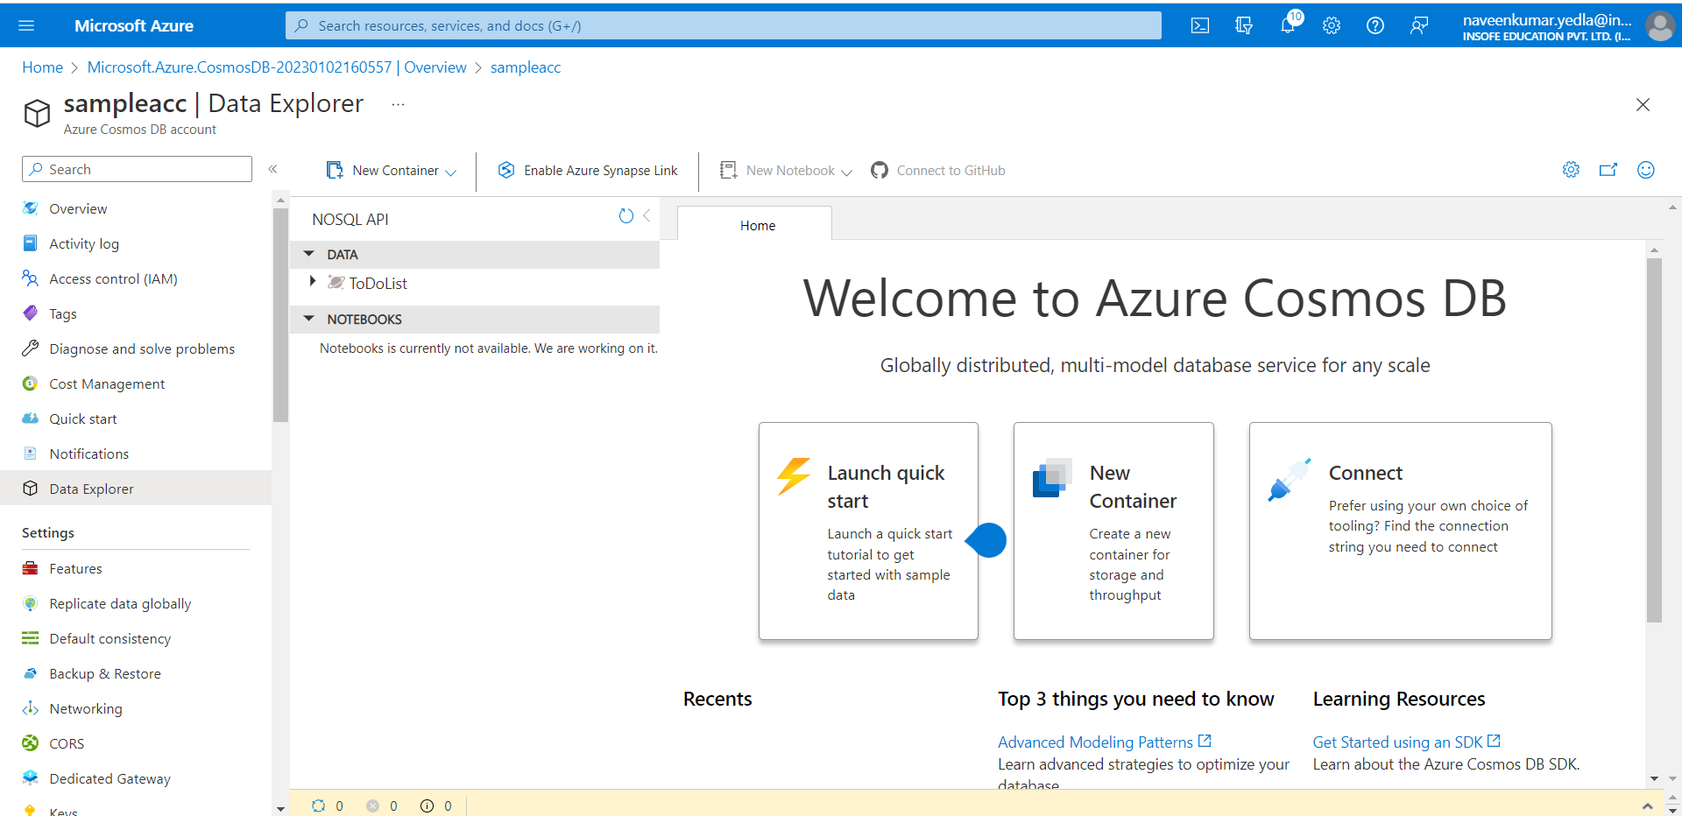

1. Upload Sample data in the container. In Data tab under the items click on new item and upload Json files.
2. The following 2 JSON items are documents about the Andersen and Wakefield families. They include parents, children and their pets, address, and registration information.
3. The first item has strings, numbers, Booleans, arrays, and nested properties:

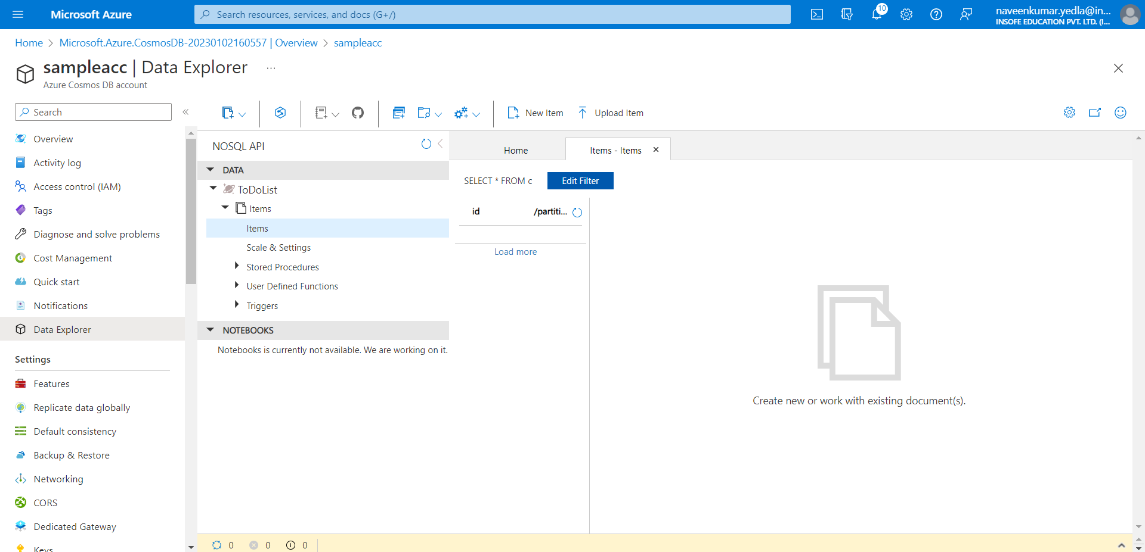

1. Upload the Json file. <https://learn.microsoft.com/en-us/azure/cosmos-db/nosql/query/getting-started> click on this link and copy the code.
2. Click on save

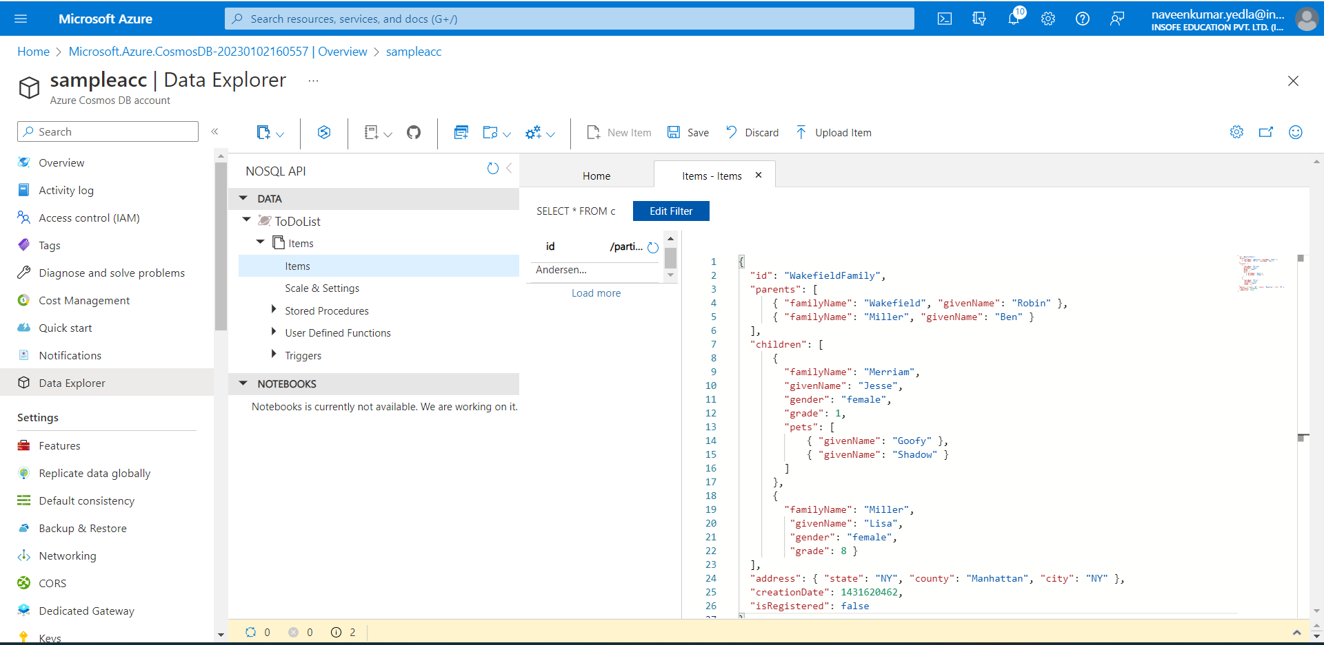

1. Run the queries on Json. Follow the steps from the above link.

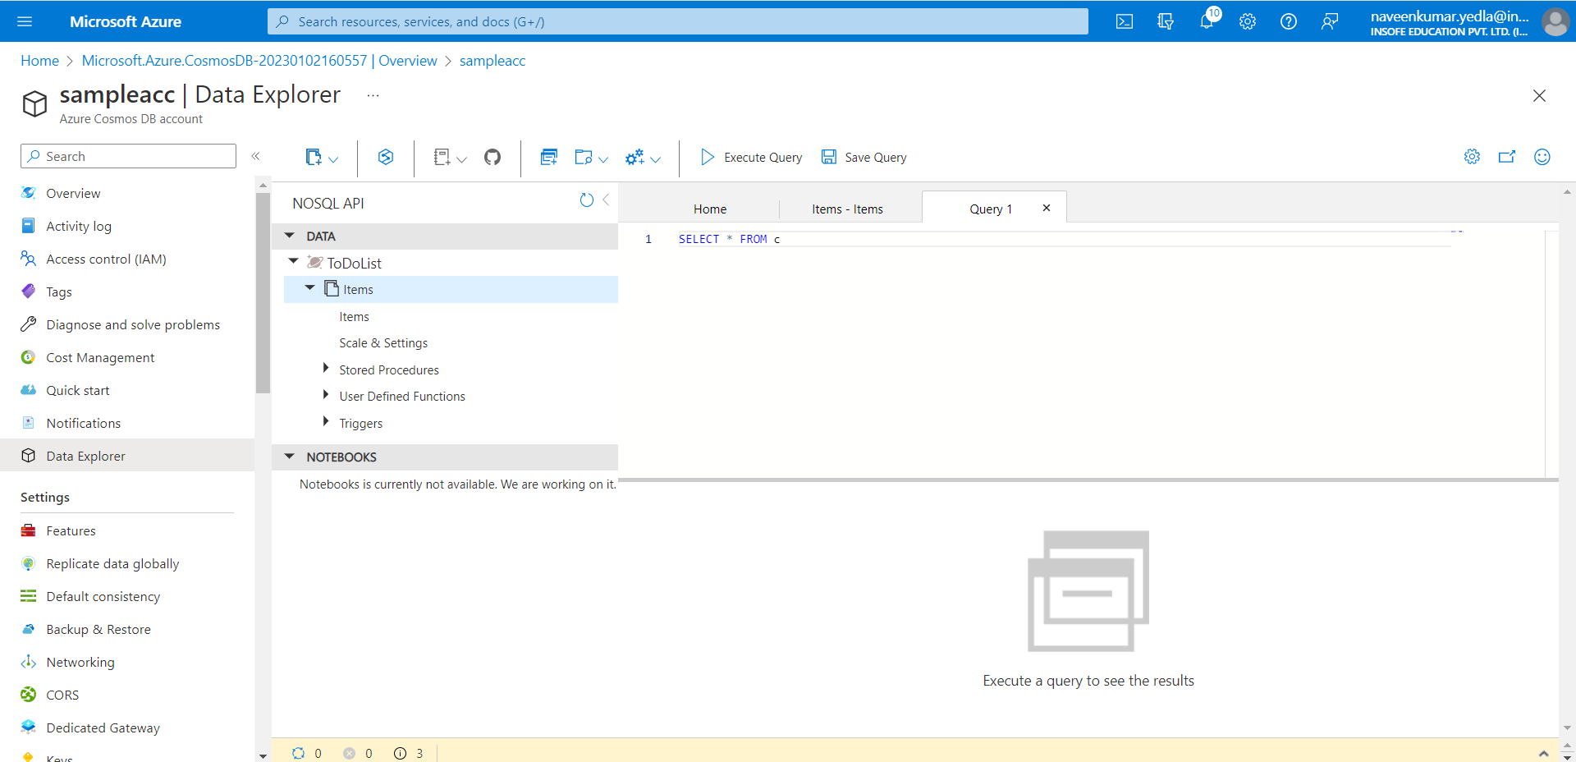

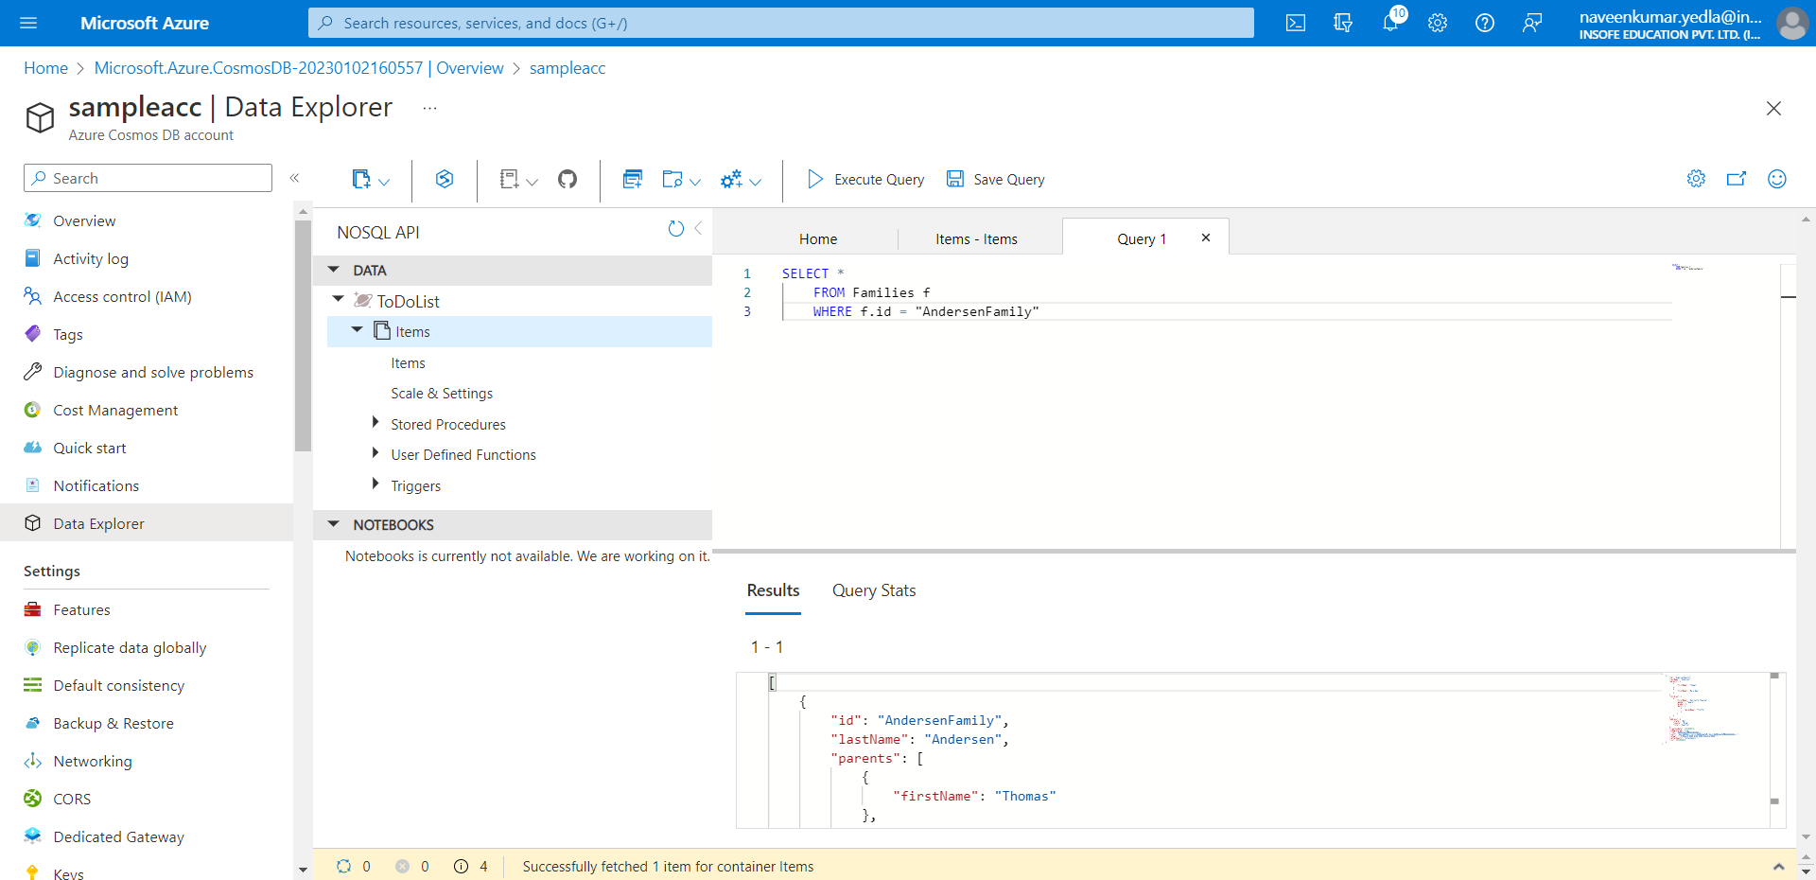

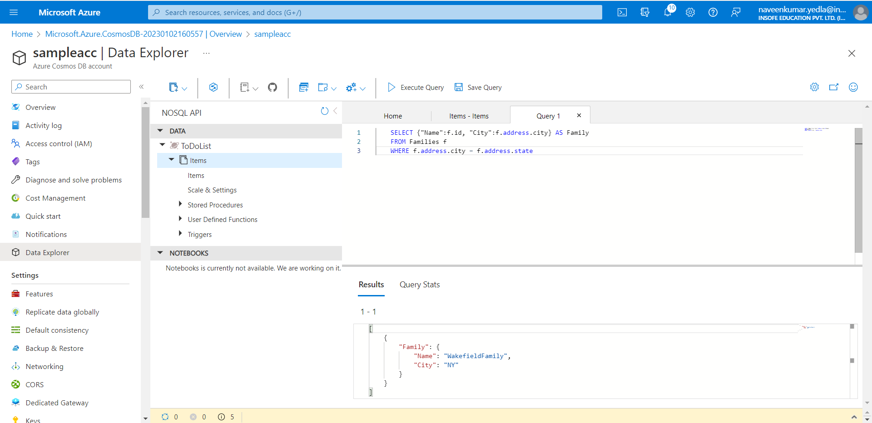

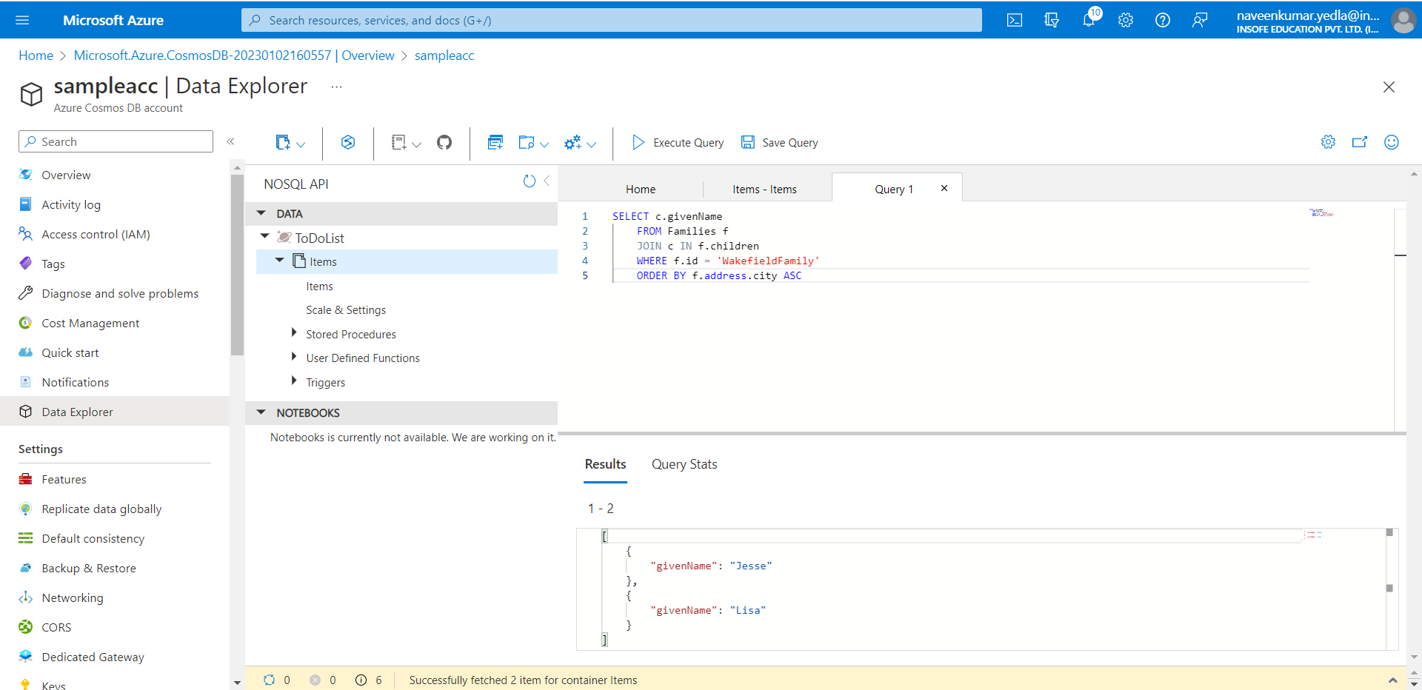

## **Clean up resources**

When you're done with the Azure Cosmos DB, select Overview select Delete.Otherwise delete the resource group.